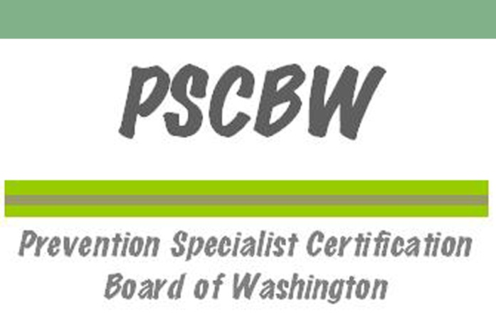

APP RENEWAL PACKET

This is not an international credential and is not recognized by the IC&RC as reciprocal.

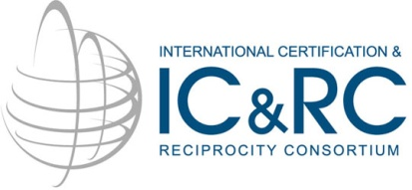

The Prevention Specialist Certification Board of Washington (PSCBW) is a member board of
the International Certification & Reciprocity Consortium (IC&RC).

Copyrighted materials © used with the permission of IC&RC, all rights reserved.

APP Renewal Packet approved by the Board of Directors, January 20, 2012. Revised March 15, 2016.
The Associate Prevention Professional (APP) certificate can be renewed for one additional two-year period. APP’s wanting to renew their APP status must show progress toward attaining the necessary ‘training’ and ‘work experience’ required to become a CPP. Following a renewal, APP’s wishing to be certified in Washington State must apply for a Certified Prevention Professional (CPP) credential. APP’s can, however, submit an application to become a CPP at any time prior to renewal.

The APP is designed to support an applicant’s progress toward becoming a Certified Prevention Professional (CPP) in Washington State. Before completing your renewal for APP, please consider your eligibility to apply to become a Certified Prevention Professional.

Renewal and Extensions Policies

To renew your APP credential, you must complete and submit the following:

Written Progress Report- provide a written description demonstrating progress made toward attaining the necessary ‘training’ and ‘work experience’ required to become a CPP.
Complete the Quantitative Prevention Experience Form. Include the actual number of experiential hours completed since your initial APP application. If you are documenting experience at more than one agency, photocopy the blank form as needed. Ensure that the form(s) is signed by a supervisor.
Prevention Educational Prerequisites Form- submit training hours accompanied by certificates or other supporting documentation.
Current Criminal History Background Check (within one year of renewal application date)
Renewal Fee ($100)
Enclose a check, made payable to: Prevention Specialist Certification Board of Washington.
Or pay by credit or debit card – download the form from the PSCBW website and/or contact the PSCBW Treasurer, Jackie Berganio, by phone at 206-683-7972 or by email at jacjamber22@gmail.com.
Submittal of Renewal Application- submit an original of the completed candidate portfolio/application AND three (3) copies (on white paper with no staples or binding) to:

Prevention Specialist Certification Board of Washington
PO Box 7172
Spokane, Washington 99207

File Copy- keep a copy of your completed candidate portfolio/application.

If your certification has lapsed you must file for an extension, otherwise you will be removed from the APP roster. You will receive a renewal packet from PSCBW, at the APP’s last known mailing address, 30-60 days prior to the expiration date of your certification.

It is the responsibility of the APP to notify the PSCBW in writing of any contact changes such as name, address, and phone number during the two years. Lack of communication from the APP about such changes could delay the renewal process.

- The renewal applicant must demonstrate progress made in achieving the required training and work experience required to become a CPP (please review CPP requirements at www.pscbw.com). Continuing education may be acquired through college course work, workshops, in-services, training, classes, and conferences. Applicant must submit recorded training hours accompanied by a certificate/documentation.

- Program schedules, syllabi, flyer, etc. will not be accepted as documentation of participation, but accepted only as additional clarifying information. In lieu of a certificate, the applicant may submit a completed Affidavit of Attendance. This affidavit is intended to be used on a limited basis and for special circumstances, such as in the case in which the conference/training sponsor did not provide a Certificate of Completion. The Eligibility Committee will review the completed affidavit forms to determine whether these hours will be accepted. This form is available on the PSCBW website at www.pscbw.com or PreventionCertificationWA.org.

Extensions Policy

Any Associate Prevention Professional wishing to acquire an extension to renew an expiring certification must present a request for extension to the Board in writing. A 30 day grace period may be allowed upon request. An additional 90 days (120 day extension from expiration of the certificate) may be granted at a cost of $50.

Prevention Educational Prerequisites

- Include accurate documentation for each educational course/training/event that you list in this application.
  - Include as many hours and documentation as possible for each category. Additional documented hours beyond the minimum are encouraged.
  - Include photocopies of transcripts and certificates of completion/participation/attendance to your application. If the applicant does not have a certificate/transcript, the applicant may submit a completed Affidavit of Attendance. This form is available through request from the PSCBW (see page 1) and may be downloaded from the PSCBW website at www.pscbw.com or PreventionCertificationWA.org.
  - Include brief descriptions of educational courses/trainings/events. This can include syllabus, list of objectives, or a published overview of the event with delineated learning goals. This information serves only to provide further information for the PSCBW. The course description, syllabus, program brochure, etc. can NOT be substituted as documentation of actual attendance in lieu of a transcript, certificate or Affidavit of Attendance.
- Document the educational prerequisites in the categories below. Education hours must have been earned within the last two years.
  - 35 hours minimum combined from the following:
    - Drug Education (e.g., pharmacology, classification of drugs, potential for abuse/addiction, effects of drugs on the brain/body, current drug trends, addiction theory, signs and symptoms of addiction, addiction and the family, etc.) and/or
    - ATOD Prevention Education (e.g., training in evidence-based prevention strategies and programs, prevention curriculum training, planning and evaluation of prevention interventions, substance abuse in older adults, substance abuse in veterans, coordinating and/or implementing prevention activities, social marketing, community organizing, coalition development, environmental prevention strategies, etc. if specific to ATOD prevention)
  - 35 hours minimum General Prevention Education (e.g., cultural competency, behavioral health promotion, suicide prevention, HIV/AIDS prevention, community mobilization, media messages, social marketing, public policy, communication, professional growth and responsibility, etc. not specific to ATOD prevention)

To convert college credit hours into clock hours please see the key on your transcript or consult your university or college where the credits were earned.
In most cases: 1 credit = 10 clock hours

Verification of QUANTITATIVE Prevention Experience Form

Make as many photocopies of this form as needed (i.e. for each supervising agency/organization). Indicate the number of Prevention Experience Hours (documented hours of paid or volunteer experience) completed since your initial APP application. The following documentation is quantitative only.

(Reminder: the required number of hours to become a Certified Prevention Professional is 2,000 hours. This portion of your renewal is to document progress made in obtaining the number of hours needed by the end of your renewal period.)

Applicant Name:
Position Title:

Dates of Employment or Volunteer Engagement
Beginning Date: / / Ending Date: / /

Employer/Agency/Organization:

Print Name of Supervisor/Administrator/Instructor or other verifying individual:

Supervisor Position/Title:

Supervisor Phone Number:

Supervisor:

Please check only one of the boxes below to indicate the estimated total number of experiential hours in prevention accrued by the candidate under your supervision during their renewal period (past two years). If the “Other” box is checked, indicate the total estimated number of hours. Initial on the appropriate line and then sign below to verify all of the information on this form is complete and accurate.

Amount of Time Estimated Total Number of Hours Supervisor Initials
Full-time for 3 months 500 hours ________
Full-time for 6 months 1,000 hours ________
1 Full-time year 2,000 hours ________
Other: Please describe: hours ________

Supervisor’s Signature:
_____________________________________________________ ______________________
Date Signed by Supervisor

Prevention Educational Prerequisites
TITLE | DATE(S) | LOCATION | ATOD Education  and/or  ATOD Prevention Specific Education  (35 hours min.) | General Prevention Education  (35 hours min.) | TOTAL HOURS  (70 hours min.)
TOTAL HOURS THIS PAGE
IF LAST PAGE, GRAND TOTAL HOURS

Prevention Educational Prerequisites
TITLE | DATE(S) | LOCATION | ATOD Education  and/or  ATOD Prevention Specific Education  (35 hours min.) | General Prevention Education  (35 hours min.) | TOTAL HOURS  (70 hours min.)
TOTAL HOURS THIS PAGE
IF LAST PAGE, GRAND TOTAL HOURS

