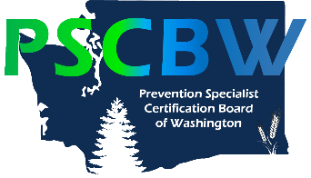
ONLINE DRUG EDUCATION RESOURCES

City Vision University: Course 413: Drugs of Abuse $600 (3 credits – 30 hours) http://www.cityvision.edu/course-413-drugs-abuse online course offered 3x/yr. 75% of course hours (22.5 hours) qualify as ATOD education.
Center for Addiction Studies and Research: https://centerforaddictionstudies.com/substance-abuse-certification/
- Alcohol Use & Abuse course: $125 (20 clock hours) – of the 7 topics, 2 would qualify as ATOD Education (6 clock hours)
- Pharmacology course $195 (45 hours) at least 20 hours of which would qualify as ATOD Education
Missouri Credentialing Board: http://www.missouricb.com/
Distance Learning Center for Addiction Studies: http://www.dlcas.com/
Pharmacology courses: https://www.dlcllc.shop/collections/all-dlcas-com-coursework include:

- Alcohol the Chemical (3 hours – $40)
- Drugs and the Brain Based on “The Science of Addiction” (6 hours – $80)
- Basic Pharmacology (6 hours – $80)
- Pharmacology Update Volume 11 – Staying Current with Drugs of Abuse (6 hours – $80)

Laban’s Trainings (private enterprise): http://www.last-homestudy.com/

- Psychopharmacology in Addiction Settings (5 hours – $45)
- Drugs of Abuse (8 hours – $65)
- Substance Abuse with Older Adults (5 hours – $45)
- Two 6-hour trainings will cost $90. ($100 – 10% Discount)

JRW Behavioral Health Services: https://shop.randallwebber.com/main.sc
- Drug Pharmacology Home Study Course (8 CEUs – $55)
- Advanced Street Drug Pharmacology Home Study Course (8 CEUs – $55)
- Synthetic and Emerging Drugs of Abuse (3 CEUs – $30)
- Pharmacology and Physiology of Alcohol and Alcoholism (6 CEUs – $45)
Wise Communications Home Study Courses: http://wisehomestudy.com/2014/search.html

