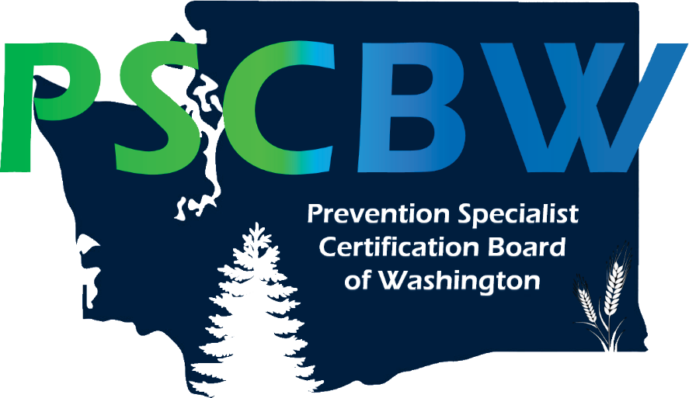

APP RENEWAL PACKET

NOTE: This is not an international credential and is not recognized by the IC&RC as reciprocal.

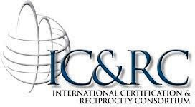

The Prevention Specialist Certification Board of Washington (PSCBW) is a member board of the International Certification & Reciprocity Consortium (IC&RC).

Copyrighted materials © used with the permission of IC&RC, all rights reserved.
APP Renewal Packet approved by the Board of Directors, January 20, 2012. Revised April 2, 2020

The Associate Prevention Professional (APP) certificate can be renewed for one additional two-year period. APPs wanting to renew their APP status must show progress toward attaining the necessary “training” and “work experience” required to become a Certified Prevention Professional (CPP). Following a renewal, APP’s wishing to be certified in Washington State must apply for the CPP credential. However, APPs can submit an application to become a CPP at any time prior to renewal.

The APP is designed to support an applicant’s progress toward becoming a Certified Prevention Professional (CPP) in Washington State. Before completing your renewal for APP, please consider your eligibility to apply to become a Certified Prevention Professional.

Renewal and Extension Policies

To renew your APP credential, you must complete and submit the following:

- Written Progress Report- provide a written description demonstrating progress made toward attaining the necessary ‘training’ and ‘work experience’ required to become a CPP.
- Complete the Quantitative Prevention Experience Form. Include the actual number of experiential hours completed since your initial APP application.
If you are documenting experience at more than one agency, photocopy the blank form as needed. Ensure that the form(s) is signed by a supervisor.
- Prevention Educational Prerequisites Form- submit training hours accompanied by certificates or other supporting documentation.
- Sign and date the Code of Ethical Conduct for Prevention Professionals.
- Submit a current Criminal History Background Check (within one year of renewal application date)
- Renewal Fee: $100
  - Pay online on the PSCBW website at http://www.pscbw.com OR
  - Enclose a check, made payable to: Prevention Specialist Certification Board of Washington.
- Submittal of Renewal Application- submit an original of the completed candidate portfolio/application AND three (3) copies (on white paper with no staples or binding) to:

Prevention Specialist Certification Board of Washington PO Box 7172
Spokane, Washington 99207

- File Copy: Keep a copy of your completed candidate portfolio/application.

If your certification has lapsed you must file for an extension, otherwise you will be removed from the APP roster. You will receive a renewal packet from PSCBW, at the APP’s last known mailing address, 30-60 days prior to the expiration date of your certification.

It is the responsibility of the APP to notify the PSCBW in writing of any contact changes such as name, address, and phone number during the two years. Lack of communication from the APP about such changes could delay the renewal process.

- The renewal applicant must demonstrate progress made in achieving the required training and work experience required to become a CPP (please review CPP requirements at www.pscbw.com). Continuing education may be acquired through college course work, workshops, in-services, training, classes, and conferences. Applicant must submit recorded training hours accompanied by a certificate/documentation.
- Program schedules, syllabi, flyer, etc. will not be accepted as documentation of participation, but accepted only as additional clarifying information. In lieu of a certificate, the applicant may submit a completed Affidavit of Attendance. This affidavit is intended to be used on a limited basis and for special circumstances, such as in the case in which the conference/training sponsor did not provide a Certificate of Completion. The Eligibility Committee will review the completed affidavit forms to determine whether these hours will be accepted. This form is available on the PSCBW website at www.pscbw.com.

Extensions Policy

Any Associate Prevention Professional wishing to acquire an extension to renew an expiring certification must present a request for extension to the Board in writing. A 30 day grace period may be allowed upon request. An additional 90 days (120 day extension from expiration of the certificate) may be granted at a cost of $50.

Prevention Educational Prerequisites

  - Include accurate documentation for each educational course/training/event that you list in this application.
    - Include as many hours and documentation as possible for each category. Additional documented hours beyond the minimum are encouraged.
    - Include photocopies of transcripts and certificates of completion/participation/attendance to your application. If the applicant does not have a certificate/transcript, the applicant may submit a completed Affidavit of Attendance. This form is available through request from the PSCBW (see page 1) and may be downloaded from the PSCBW website at www.pscbw.com or PreventionCertificationWA.org.
    - Include brief descriptions of educational courses/trainings/events. This can include syllabus, list of objectives, or a published overview of the event with delineated learning goals. This information serves only to provide further information for the PSCBW. The course description, syllabus, program brochure, etc. can NOT be substituted as documentation of actual attendance in lieu of a transcript, certificate or Affidavit of Attendance.
  - Document the educational prerequisites in the categories below. Education hours must have been earned within the last two years.
    - 35 hours minimum combined from the following:
      - Drug Education (e.g., pharmacology, classification of drugs, potential for abuse/addiction, effects of drugs on the brain/body, current drug trends, addiction theory, signs and symptoms of addiction, addiction and the family, etc.) and/or
      - ATOD Prevention Education (e.g., training in evidence-based prevention strategies and programs, prevention curriculum training, planning and evaluation of prevention interventions, substance abuse in older adults, substance abuse in veterans, coordinating and/or implementing prevention activities, social marketing, community organizing, coalition development, environmental prevention strategies, etc. if specific to ATOD prevention)
    - 35 hours minimum General Prevention Education (e.g., cultural competency, behavioral health promotion, suicide prevention, HIV/AIDS prevention, community mobilization, media messages, social marketing, public policy, communication, professional growth and responsibility, etc. not specific to ATOD prevention)

To convert college credit hours into clock hours, please see the key on your transcript or consult your university or college where the credits were earned. In most cases: 1 credit = 10 clock hours.

Verification of QUANTITATIVE Prevention Experience Form

Make as many photocopies of this form as needed (i.e. for each supervising agency/organization). Indicate the number of Prevention Experience Hours (documented hours of paid or volunteer experience) completed since your initial APP application. The following documentation is quantitative only.

(Reminder: The required number of hours to become a Certified Prevention Professional is 2,000 hours. This portion of your renewal is to document progress made in obtaining the number of hours needed by the end of your renewal period.)

Applicant Name:
Position Title:
Dates of Employment or Volunteer Engagement
Beginning Date: / / Ending Date: / /
Employer/Agency/Organization:
Print Name of Supervisor/Administrator/Instructor or Other Verifying Individual:
Supervisor Position/Title:
Supervisor Phone Number:
Supervisor Verification:

Please check only one of the boxes below to indicate the estimated total number of experiential hours in prevention accrued by the candidate under your supervision during their renewal period (past two years). If the “Other” box is checked, indicate the total estimated number of hours. Initial on the appropriate line and then sign below to verify all of the information on this form is complete and accurate.

Amount of Time Estimated Total Number of Hours Supervisor Initials
- Full-time for 3 months 500 hours
- Full-time for 6 months 1,000 hours
- Full-time year 2,000 hours
- Other: (Please describe) hours

Supervisor’s Signature:

Date Signed by Supervisor

Prevention Education Prerequisites

TITLE | DATE(S) | LOCATION | ATOD Education and/or  ATOD Prevention Specific Education  (35 hours min.) | General Prevention Education  (35 hours min.) | TOTAL HOURS  (70 hours min.)
TOTAL HOURS
(this page)
GRAND TOTAL
(if last page)

TITLE | DATE(S) | LOCATION | ATOD Education and/or  ATOD Prevention Specific Education  (35 hours min.) | General Prevention Education  (35 hours min.) | TOTAL HOURS  (70 hours min.)
TOTAL HOURS
(this page)
GRAND TOTAL
(if last page)
Prevention Education Prerequisites

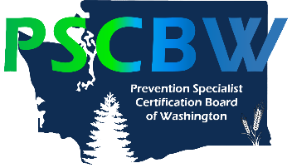
PSCBW Prevention Code of Ethical Conduct
Fee Schedule

Adapted from Prevention Think Tank, Inc. - Revised November 2017

Preamble

The prevention code of ethical conduct principles are models of exemplary professional behavior. These principles express prevention professionals’ recognition of responsibilities to the public, to service recipients, and to colleagues within and outside of the prevention field. They guide prevention professionals in the performance of their professional responsibilities and express the basic tenets of ethical and professional conduct. Prevention professionals shall adhere to the same principles of professionalism online as they would offline. The principles call for honorable behavior, even at the sacrifice of personal advantage. These principles shall not be regarded as limitations or restrictions, but as goals toward which prevention professionals shall constantly strive. They are guided by core values and competencies that have emerged with the development of the prevention field.

Principles

Principle 1: Non-discrimination.

A prevention professional shall not discriminate against service recipients or colleagues based on race, religion, national origin, sex, age, sexual orientation, gender identity, economic condition or physical, medical or mental disability. A prevention professional shall broaden their understanding and acceptance of cultural and individual differences, and in so doing, render services and provide information sensitive to those differences.
Prevention professionals shall comply with all local, state and federal laws.

Principle 2: Competency

Prevention professionals shall master their prevention specialty’s body of knowledge and skill competencies, strive continually to improve personal proficiency and quality of service delivery, and discharge professional responsibility to the best of their ability. Competence includes a synthesis of education and experience combined with an understanding of the cultures within which prevention application occurs. The maintenance of competence requires continual learning and professional improvement throughout one’s career.

- Professionals shall be diligent in discharging responsibilities. Diligence imposes the responsibility to render services carefully and promptly, to be thorough, and to observe applicable technical and ethical standards.
- Due care requires a professional to plan and supervise adequately and evaluate to the extent possible any professional activity for which he or she is responsible.
- A prevention professional shall recognize limitations and boundaries of competencies and not use techniques or offer services outside of his or her competencies. Each professional is responsible for assessing the adequacy of his or her own competence for the responsibility to be assumed. When asked to perform such services, a prevention professional shall, to the best of their ability, refer to an appropriately qualified professional. When no such professional exists, a prevention professional shall clearly notify the requesting person/organization of the gap in services available.
- Ideally, prevention professionals shall be supervised by competent senior prevention professionals. When this is not possible, prevention professionals shall seek peer supervision or mentoring from other competent prevention professionals.
- When a prevention professional has knowledge of unethical conduct or practice on the part of an agency or prevention professional, he or she has an ethical responsibility to report the conduct or practices to funding, regulatory or other appropriate bodies.
- A prevention professional shall recognize the effect of impairment on professional performance and shall be willing to seek appropriate professional assistance for any form of substance misuse, psychological impairment, emotional distress, or any other physical related adversity that interferes with their professional functioning.
- Prevention professionals shall not permit students, employees, or supervisees to perform or to hold themselves out as competent to perform professional services beyond their training, level of experience and competence.
- Prevention professionals who supervise others accept the obligation to facilitate further professional development of these individuals by providing accurate and current information, timely evaluations, and constructive consultation.

Principle 3: Integrity.

To maintain and broaden public confidence, prevention professionals shall perform all responsibilities with the highest sense of integrity. Personal gain and advantage shall not subordinate service and the public trust. Integrity can accommodate the inadvertent error and the honest difference of opinion. It cannot accommodate deceit or subordination of principle.

- All information shall be presented fairly and accurately. Each professional shall document and assign credit to all contributing sources used in published material or public statements.
- Prevention professionals shall not misrepresent either directly or by implication professional qualifications or affiliations.
- Where there is evidence of impairment in a colleague or a service recipient, a prevention professional shall be supportive of assistance or treatment.
- Prevention professionals shall not be associated directly or indirectly with any service, products, individuals, and organizations in a way that is misleading.
- Prevention professionals shall cooperate with the Ethics Committee of the Prevention Specialist Certification Board of Washington.

If a Prevention Professional is found to have committed an ethical violation by another discipline or jurisdiction, the Prevention Professional must immediately report the violation to the Ethics Committee of the Prevention Specialist Certification Board of Washington.

Principle 4: Nature of Services.

Practices shall do no harm to service recipients. Services provided by prevention professionals shall be respectful and non-exploitive.

      - Services shall be provided in a way that preserves the protective factors inherent in each culture and individual.
      - Prevention professionals shall use formal and informal structures to receive and incorporate input from service recipients in the development, implementation and evaluation of prevention services.
      - Where there is suspicion of abuse of children or vulnerable adults, the prevention professional shall report the evidence to the appropriate agency and follow up to ensure that appropriate action has been taken.

Principle 5: Confidentiality.

Confidential information acquired during service delivery shall be safe guarded from disclosure, including – but not limited to – verbal disclosure, unsecured maintenance of records, or recording of an activity or presentation without appropriate releases. Prevention professionals are responsible for knowing the confidentiality regulations relevant to their prevention specialty.
Principle 6: Ethical Obligations for Community and Society.

According to their consciences, prevention professionals shall be proactive on public policy and legislative issues. The public welfare and the individual’s right to services and personal wellness shall guide the efforts of prevention professionals to educate the general public and policy makers. Prevention professionals shall adopt a personal and professional stance that promotes health.
Prevention Professionals shall be aware of their local and national regulations regarding lobbying and advocacy, and act within the laws and funding guidelines.

I have read and understand the Prevention Code of Ethical Conduct and will adhere to and honor this Code to the best of my ability.

____________________
Applicant Signature Date

_________________________________________
Applicant Name (Printed)

Revised April 2020

